**SPRINT 2**

**Create User Registration Form in Node Red and upload the registration deatails to cloudant DB**

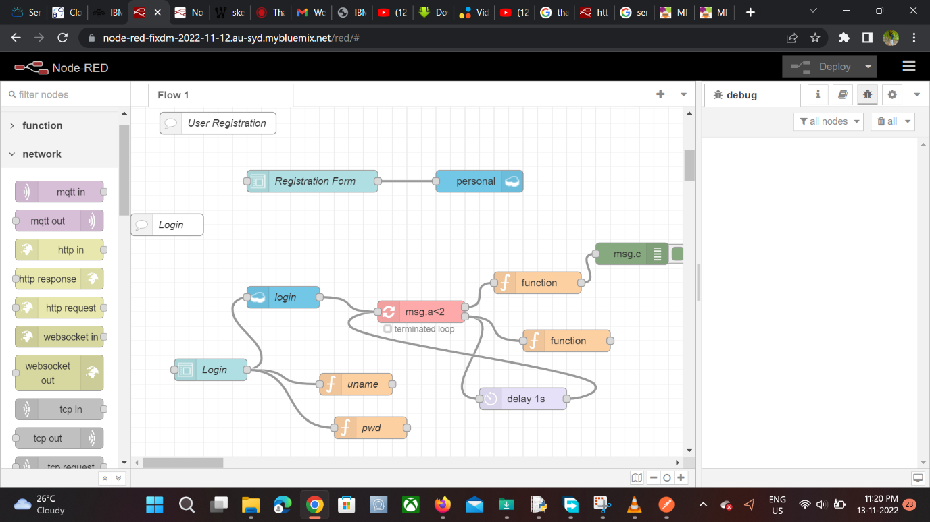

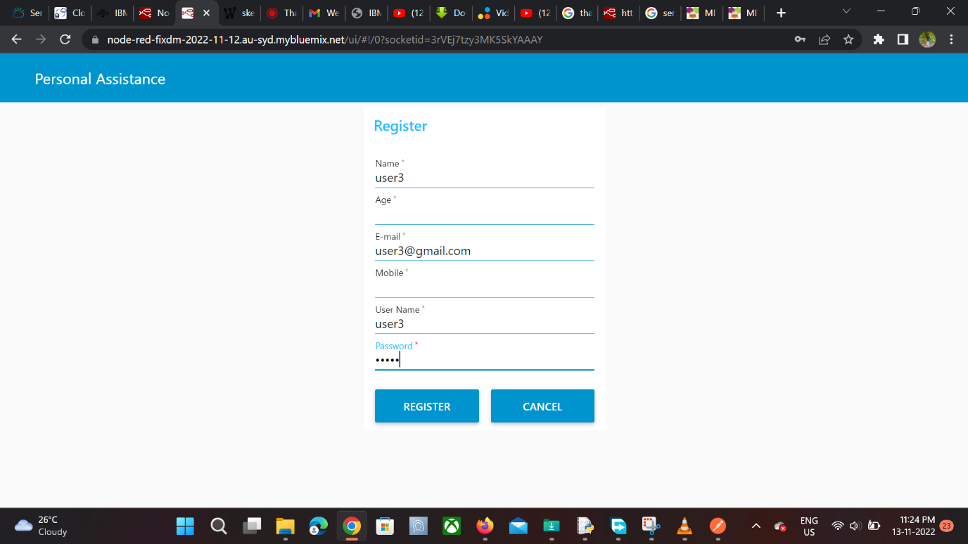

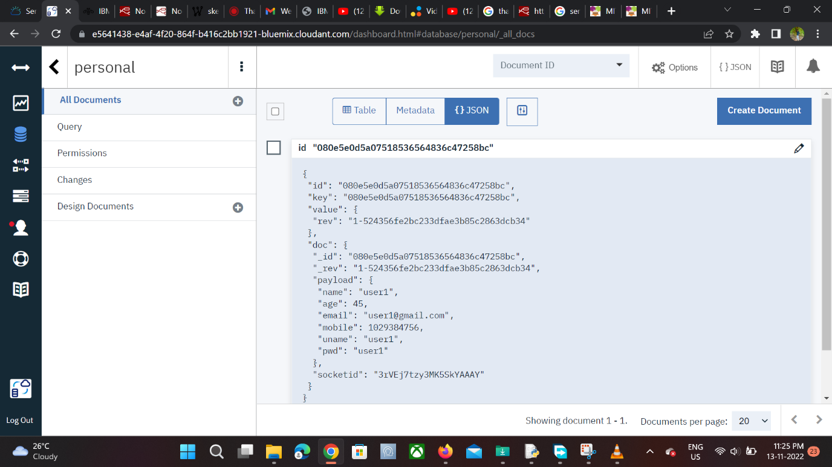

**Create a Login Form in Node Red and Check the credentials with the data in Cloudant DB**



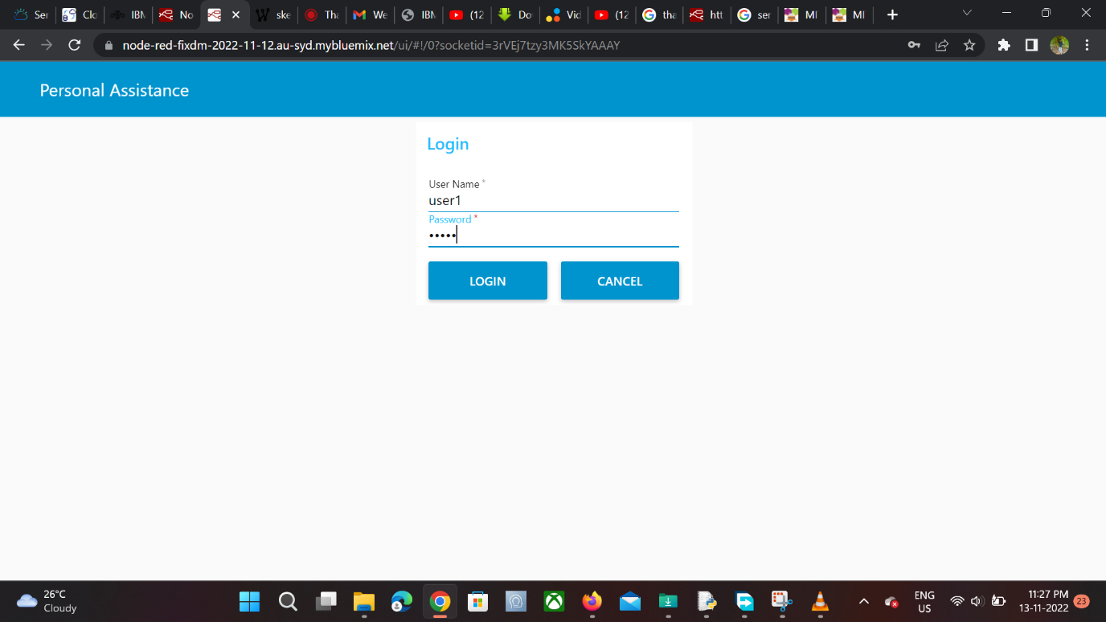

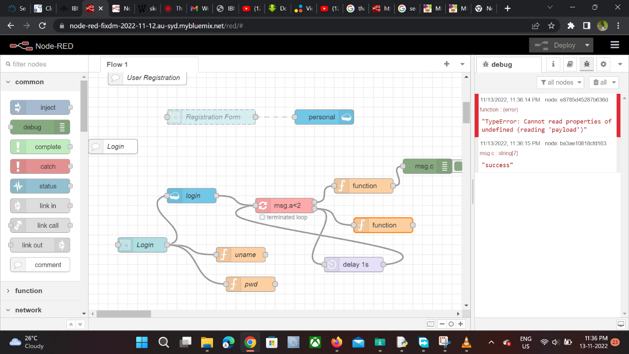

**Create Medicine Registration form in Node Red and save the medicine details in cloudant DB**

